ASSIGNMENT – 4.2
NAME : AJMERA RUCHITHA
BATCH : 33
HALL TICKET NUMBER : 2303A52365
Task Description-1
• Zero-shot: Prompt AI with only the instruction. Write a Python function to determine
whether a given number is prime
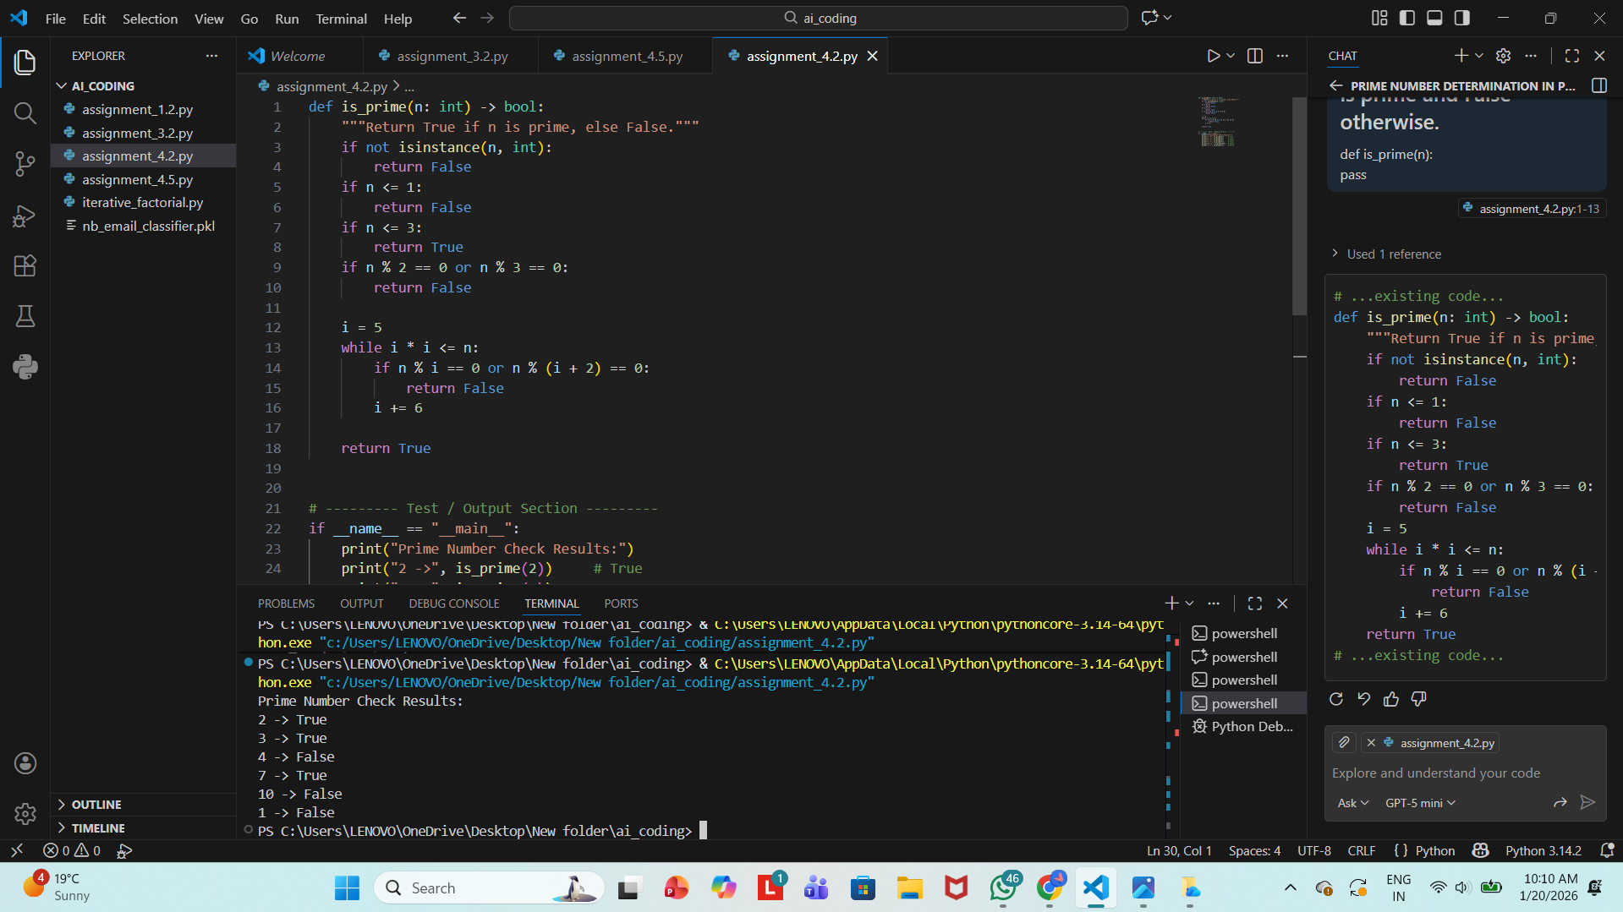

Task Description-2
• One-shot: Provide one example: Input: [1, 2, 3, 4], Output: 10 to help AI generate a
function that calculates the sum of elements in a list.
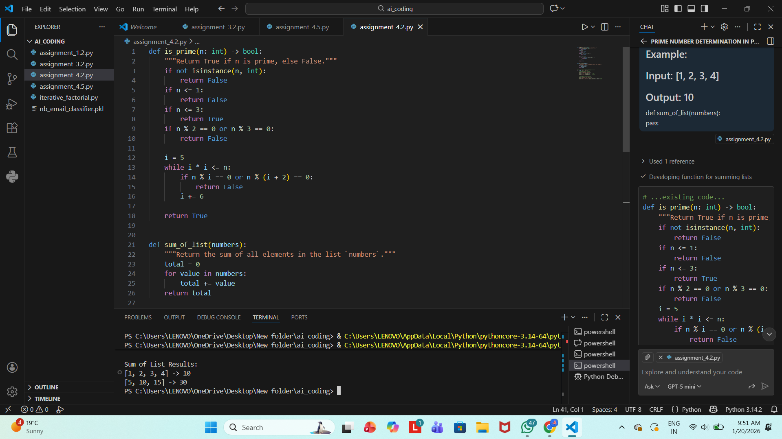

Task Description-3
• Few-shot: Give 2–3 examples to create a function that extracts digits from an
alphanumeric string.
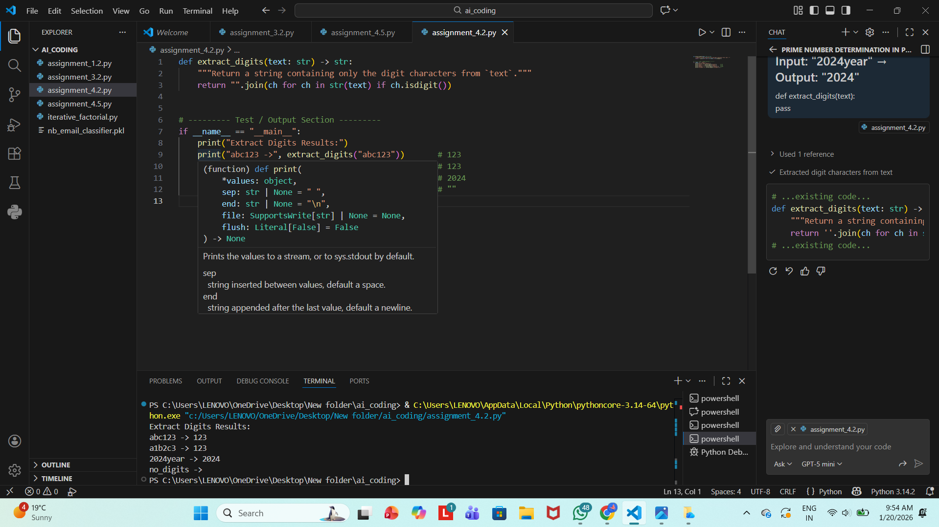

Task Description-4
• Compare zero-shot vs few-shot prompting for generating a function that counts the
number of vowels in a string.
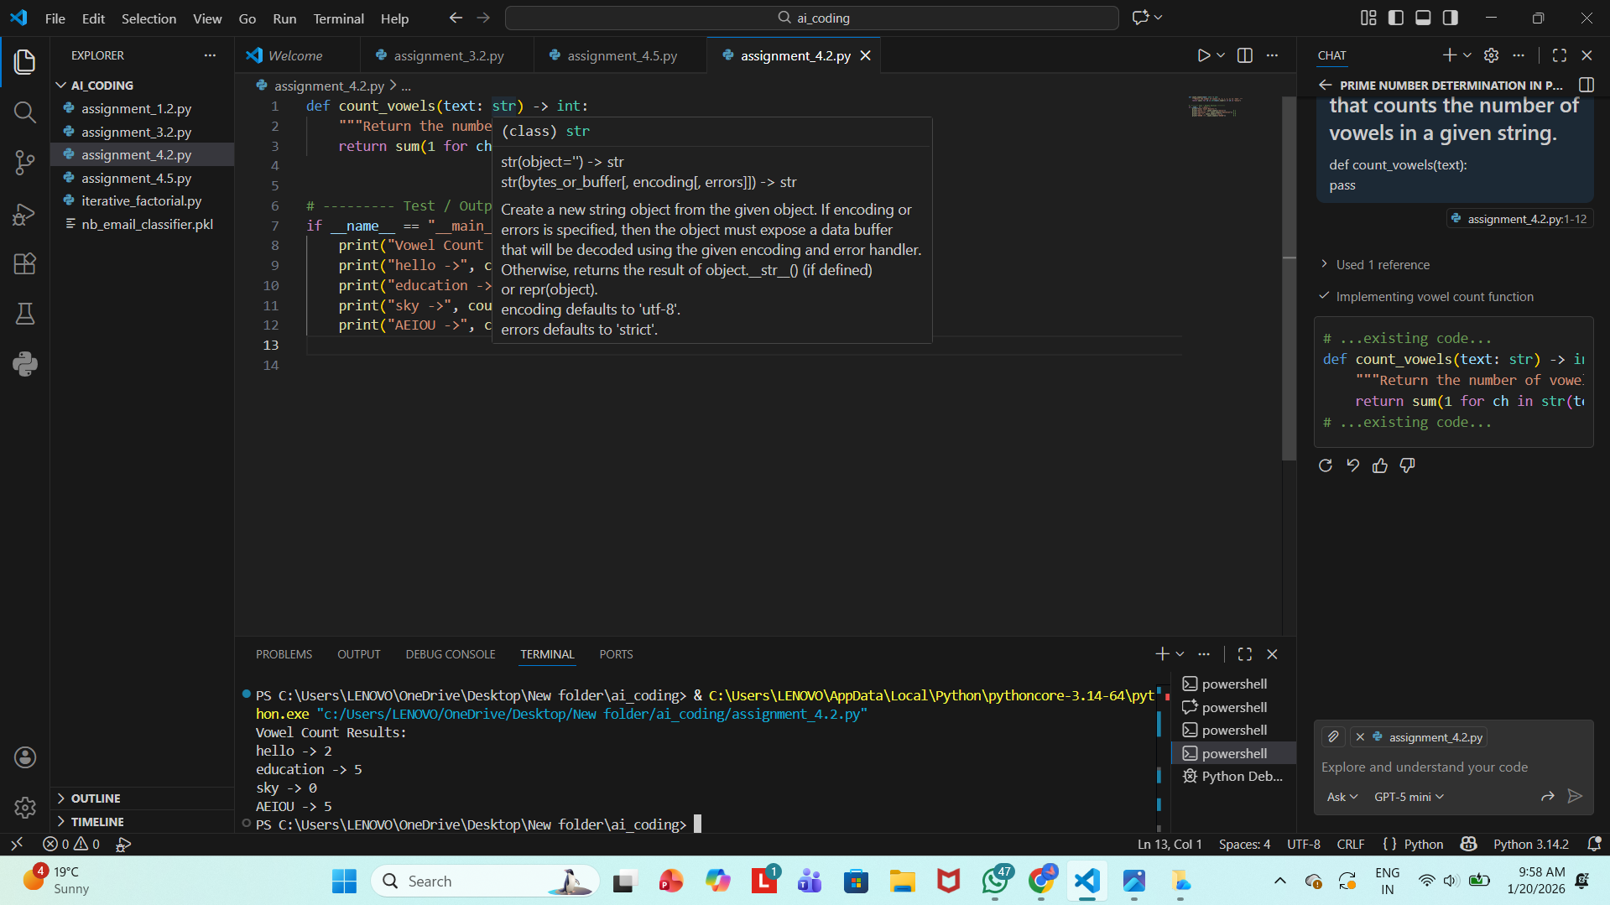

Task Description-5
• Use few-shot prompting with 3 sample inputs to generate a function that determines
the minimum of three numbers without using the built-in min() function.
